Angle Drilling Frame

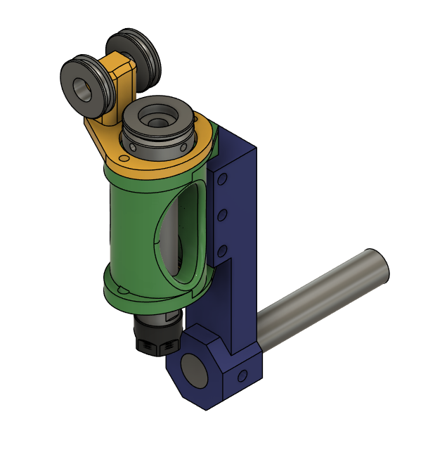

This uses the 3d printed drilling frame in addition to a rotatable arm. It is held in an AXA boring bar holder.

Parts List:

|  |  |
| --- | --- |
| **Quantity** | **Description** |
| 4 | 695 Bearing  (no flange) used in the idler wheels |
| 2 | M5x10 Shoulder bolt with M4 thread |
| 8 | M5 Heat set insert |
| 2 | M4 Heat set insert |
| 1 | 3/4"x4.125" Steel rod |
| 6 | M5x12 SHCS |
| 1 | AXA holder 250-104 |
| 1 | 3d printed drill frame with ER chuck |
| 2 | 3d printed pulleys |
| 1 | 3d printed main arm |
| 1 | 3d printed pulley mount |

3d Print Settings:

|  |  |
| --- | --- |
| **Setting** | **Value** |
| Filament | ABS-GF |
| Walls | 8 |
| Infill % | 40 |
| Infill Pattern | Cubic |
| Support | Tree Slim |
| Brim | Outer 15mm |

The file, AngleDrillFrame_10mm_Bore.3mf, contains all of the parts for the drill frame housing and the angle drill frame parts for an ER chuck with a 10mm shaft.

The file, AngleDrillFrame_12_and_20mm_Bore.3mf, contains all of the parts for the drill frame housing and the angle drill frame parts for an ER chuck with a 20mm and a 12mm shaft (Only the pulley differs).